* The scope of object that is placed in the method is having the method schope.
* The scope of object that is placed as instance varible is having object scope.
* The scope of the object that is placed as static variable is having class scope.

If we want to provide more visibility to object or object ref then it need to be placed in special software called **“JNDI Registry**”. Once the objects are placed in JNDI registy, the objects can be accessed from same computer or remote computer. We generally place more useful objects in JNDI registry like DataSource object ref, gpay object ref, phone pe object ref ,Visa object ref and etc…

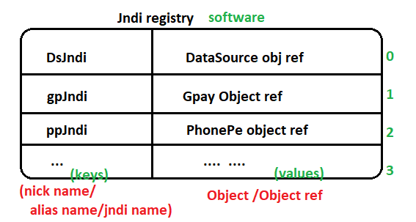

* JNDI stands for Java Naming and Directory Interface.
* It is an api/technology of JSE module(part of jdk s/w) that is given to interace with jndi registry software.

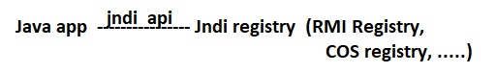

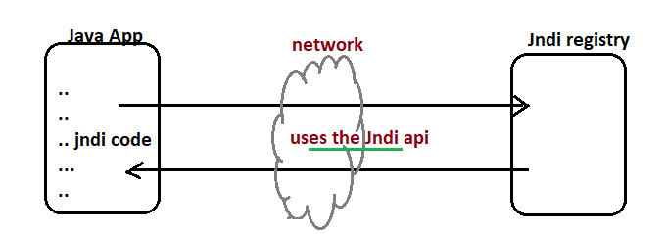

This api have javax.naming and its sub packages.

* Every webserver or Application server gives one built-in JNDI registry.

Ex: Tomcat server gives Tomcat registry.

GlashFish server gives glassfish registry.

Weblogic server gives web logic registry.

1. Steps to create and perform operation in JNDI Registry.

Step1: Establish connection between java App and JNDI registry.



The Initial context object represent the connectivity between java app and JNDI registry.

Step2:- we can perform JNDI operations on JNDI registry using initialContext object.

* Bind Operation( keep the object ref in the jndi registry)
* ReBind Operation( Replacing object ref from jndi registry)
* Unbind operation(removing the object ref from jndi registry)
* Lookup operation(Searching and getting object ref from jndi registry)